1. Introduction
This report presents the security risk analysis of a sample API endpoint (/users) from JSONPlaceholder. The objective is to identify vulnerabilities in handling user data and recommend security measures.
2. Methodology
- Tool Used: Postman
- Workspace: Internal (private)
- Request Type: GET
- Endpoint Tested:
https://jsonplaceholder.typicode.com/users
3. Evidence
- The API returned 232 lines of JSON response.
- Representative screenshots (34 lines) are attached in the Evidence section.
- Data fields included:
- id, name, username, email, address, phone, website, company.
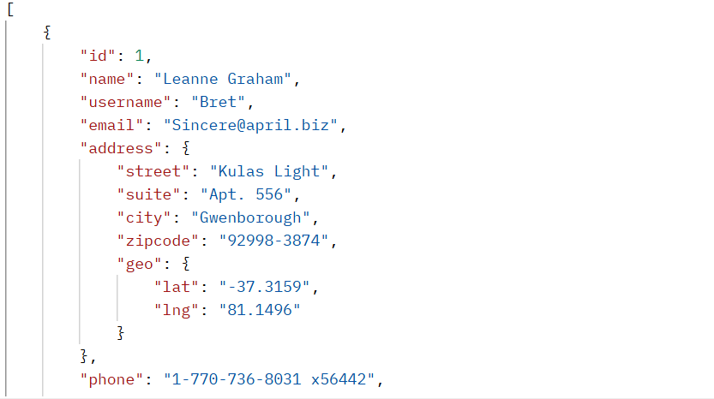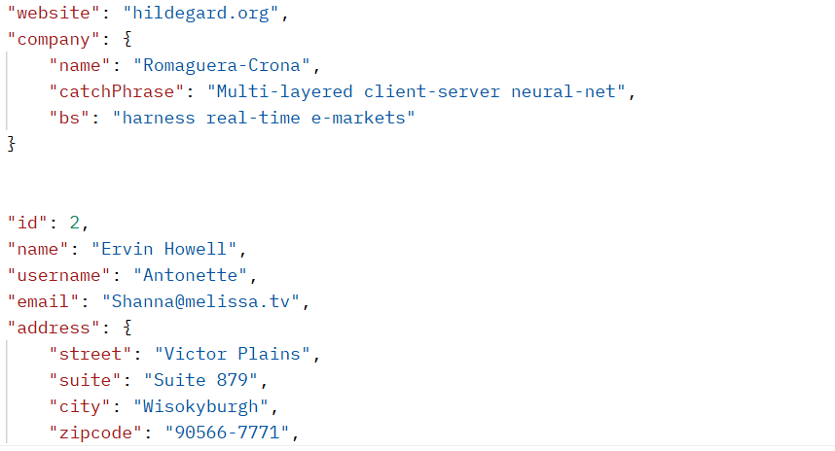
4. Findings
1. Sensitive Data Exposure
- Personal details (name, email, phone, address) are openly visible.
- This creates privacy risks.

2. Lack of Access Control
- No authentication required to access the endpoint.
- Anyone can retrieve user data → Access Control Risk.

3. Potential Misuse of Information
- Exposed emails and phone numbers can be misused for spam, phishing, or social engineering.
- This is an Information Disclosure Risk.
5. Recommendations
- Implement Authentication & Authorization (API keys, OAuth).
- Apply Data Minimization: expose only necessary fields.
- Use Rate Limiting to prevent abuse.
- Encrypt sensitive data in transit (HTTPS) and at rest.
- Monitor and log API access for suspicious activity.
6. Conclusion
The tested API endpoint demonstrates how exposing user data without security controls can lead to privacy and misuse risks. By implementing proper authentication, minimizing data exposure, and enforcing security best practices, these risks can be mitigated.
Appendix A – Full API Response
[
{
"id": 1,
"name": "Leanne Graham",
"username": "Bret",
"email": "Sincere@april.biz",
"address": {
"street": "Kulas Light",
"suite": "Apt. 556",
"city": "Gwenborough",
"zipcode": "92998-3874",
"geo": {
"lat": "-37.3159",
"lng": "81.1496"
}
},
"phone": "1-770-736-8031 x56442",
"website": "hildegard.org",
"company": {
"name": "Romaguera-Crona",
"catchPhrase": "Multi-layered client-server neural-net",
"bs": "harness real-time e-markets"
}
},
{
"id": 2,
"name": "Ervin Howell",
"username": "Antonette",
"email": "Shanna@melissa.tv",
"address": {
"street": "Victor Plains",
"suite": "Suite 879",
"city": "Wisokyburgh",
"zipcode": "90566-7771",
"geo": {
"lat": "-43.9509",
"lng": "-34.4618"
}
},
"phone": "010-692-6593 x09125",
"website": "anastasia.net",
"company": {
"name": "Deckow-Crist",
"catchPhrase": "Proactive didactic contingency",
"bs": "synergize scalable supply-chains"
}
},
{
"id": 3,
"name": "Clementine Bauch",
"username": "Samantha",
"email": "Nathan@yesenia.net",
"address": {
"street": "Douglas Extension",
"suite": "Suite 847",
"city": "McKenziehaven",
"zipcode": "59590-4157",
"geo": {
"lat": "-68.6102",
"lng": "-47.0653"
}
},
"phone": "1-463-123-4447",
"website": "ramiro.info",
"company": {
"name": "Romaguera-Jacobson",
"catchPhrase": "Face to face bifurcated interface",
"bs": "e-enable strategic applications"
}
},
{
"id": 4,
"name": "Patricia Lebsack",
"username": "Karianne",
"email": "Julianne.OConner@kory.org",
"address": {
"street": "Hoeger Mall",
"suite": "Apt. 692",
"city": "South Elvis",
"zipcode": "53919-4257",
"geo": {
"lat": "29.4572",
"lng": "-164.2990"
}
},
"phone": "493-170-9623 x156",
"website": "kale.biz",
"company": {
"name": "Robel-Corkery",
"catchPhrase": "Multi-tiered zero tolerance productivity",
"bs": "transition cutting-edge web services"
}
},
{
"id": 5,
"name": "Chelsey Dietrich",
"username": "Kamren",
"email": "Lucio_Hettinger@annie.ca",
"address": {
"street": "Skiles Walks",
"suite": "Suite 351",
"city": "Roscoeview",
"zipcode": "33263",
"geo": {
"lat": "-31.8129",
"lng": "62.5342"
}
},
"phone": "(254)954-1289",
"website": "demarco.info",
"company": {
"name": "Keebler LLC",
"catchPhrase": "User-centric fault-tolerant solution",
"bs": "revolutionize end-to-end systems"
}
},
{
"id": 6,
"name": "Mrs. Dennis Schulist",
"username": "Leopoldo_Corkery",
"email": "Karley_Dach@jasper.info",
"address": {
"street": "Norberto Crossing",
"suite": "Apt. 950",
"city": "South Christy",
"zipcode": "23505-1337",
"geo": {
"lat": "-71.4197",
"lng": "71.7478"
}
},
"phone": "1-477-935-8478 x6430",
"website": "ola.org",
"company": {
"name": "Considine-Lockman",
"catchPhrase": "Synchronised bottom-line interface",
"bs": "e-enable innovative applications"
}
},
{
"id": 7,
"name": "Kurtis Weissnat",
"username": "Elwyn.Skiles",
"email": "Telly.Hoeger@billy.biz",
"address": {
"street": "Rex Trail",
"suite": "Suite 280",
"city": "Howemouth",
"zipcode": "58804-1099",
"geo": {
"lat": "24.8918",
"lng": "21.8984"
}
},
"phone": "210.067.6132",
"website": "elvis.io",
"company": {
"name": "Johns Group",
"catchPhrase": "Configurable multimedia task-force",
"bs": "generate enterprise e-tailers"
}
},
{
"id": 8,
"name": "Nicholas Runolfsdottir V",
"username": "Maxime_Nienow",
"email": "Sherwood@rosamond.me",
"address": {
"street": "Ellsworth Summit",
"suite": "Suite 729",
"city": "Aliyaview",
"zipcode": "45169",
"geo": {
"lat": "-14.3990",
"lng": "-120.7677"
}
},
"phone": "586.493.6943 x140",
"website": "jacynthe.com",
"company": {
"name": "Abernathy Group",
"catchPhrase": "Implemented secondary concept",
"bs": "e-enable extensible e-tailers"
}
},
{
"id": 9,
"name": "Glenna Reichert",
"username": "Delphine",
"email": "Chaim_McDermott@dana.io",
"address": {
"street": "Dayna Park",
"suite": "Suite 449",
"city": "Bartholomebury",
"zipcode": "76495-3109",
"geo": {
"lat": "24.6463",
"lng": "-168.8889"
}
},
"phone": "(775)976-6794 x41206",
"website": "conrad.com",
"company": {
"name": "Yost and Sons",
"catchPhrase": "Switchable contextually-based project",
"bs": "aggregate real-time technologies"
}
},
{
"id": 10,
"name": "Clementina DuBuque",
"username": "Moriah.Stanton",
"email": "Rey.Padberg@karina.biz",
"address": {
"street": "Kattie Turnpike",
"suite": "Suite 198",
"city": "Lebsackbury",
"zipcode": "31428-2261",
"geo": {
"lat": "-38.2386",
"lng": "57.2232"
}
},
"phone": "024-648-3804",
"website": "ambrose.net",
"company": {
"name": "Hoeger LLC",
"catchPhrase": "Centralized empowering task-force",
"bs": "target end-to-end models"
}
}
]

